store.enayah.sa

Performance Test report

www.programmer.com

# **Test Details**

* **Test Date:** 05/16/2020
* **Load:** 100 Users
* **Duration:** 20 Mins
* **Environment:** store.enayah.sa
* **Functionalities Covered :** Quick Links Navigation, Donation(with Cheque Upload), User Registration) and Banner Links Navigation
* **Load distribution: (Concurrent Users)**
  + Donations : 50 Users
  + User Registration : 10 Users
  + Banner links : 10
  + Quick links : 30

# **Observations & Recommendations**

* Application was tested with 100 concurrent users with the load distribution mentioned above.
* Homepage/Landing page was very slow initially and recovered as load was increasing. For few users, response time spiked up to 4 minutes.
* There are several errors observed for every page i.e, 500 internal Server Error, due to server was unable to process the load at some point.

# **Response Time Summary**

|  |  |  |  |  |  |  |
| --- | --- | --- | --- | --- | --- | --- |
| **Transaction/Page** | **# Samples** | **Average** | **90% Line** | **Min** | **Max** | **Error %** |
| 01-OpenURL | 2067 | 5.47 | 2.62 | 0.00 | 234.49 | 5.95% |
| **Banner Links** | | | | | | |
| BannerLinks_02_ClickRandomBannerLink | 400 | 2.78 | 3.62 | 0.00 | 111.14 | 0.00% |
| BannerLinks_03_GotoHome | 393 | 2.27 | 3.69 | 0.00 | 106.23 | 0.00% |
| **Create Account** | | | | | | |
| Create Account _02_ClickCreateAccountLink | 274 | 3.02 | 4.74 | 0.00 | 112.38 | 0.00% |
| Create Account _03_FilleDetails&Submit | 272 | 2.62 | 3.73 | 0.00 | 113.19 | 1.10% |
| Create Account _04_Logout | 266 | 1.94 | 3.68 | 0.00 | 32.14 | 0.00% |
| **Donations** | | | | | | |
| Donations_02_SubmitLogin | 663 | 3.28 | 7.57 | 0.00 | 119.59 | 0.00% |
| Donations_03_SelectARandomDonations | 660 | 7.05 | 9.21 | 0.00 | 126.69 | 0.30% |
| Donations_04_DonateLink | 648 | 2.76 | 5.80 | 0.00 | 121.60 | 0.31% |
| Donations_05_SubmitAttachment | 645 | 8.54 | 11.52 | 0.00 | 116.80 | 22.48% |
| Donations_06_DonationsHistory | 481 | 1.60 | 3.58 | 0.00 | 30.40 | 2.50% |
| Donations_07_Logout | 466 | 1.52 | 3.66 | 0.00 | 31.21 | 0.00% |
| **Quick links Navigations** | | | | | | |
| QucikLinksDetails_02_ViewRandomQuickLink | 604 | 8.12 | 9.08 | 0.00 | 148.13 | 3.31% |
| QucikLinksDetails_03_ViewDetails | 572 | 2.62 | 3.68 | 0.00 | 119.38 | 0.52% |
| QucikLinksDetails_04_ClickOnProject | 568 | 0.05 | 0.00 | 0.00 | 2.63 | 0.00% |

# Concurrent Users

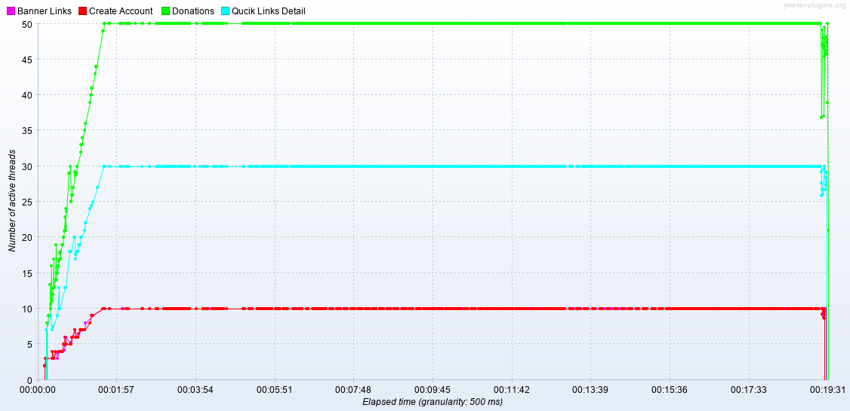

# Response time over time

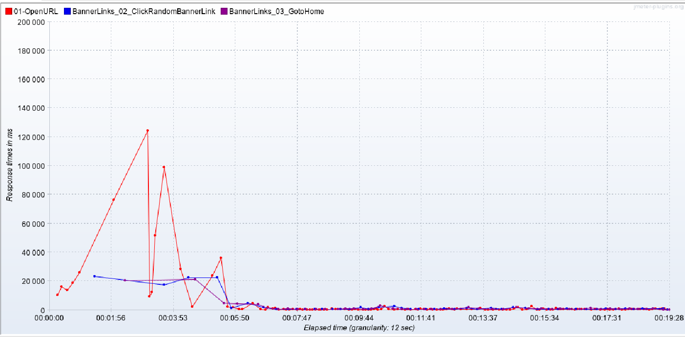

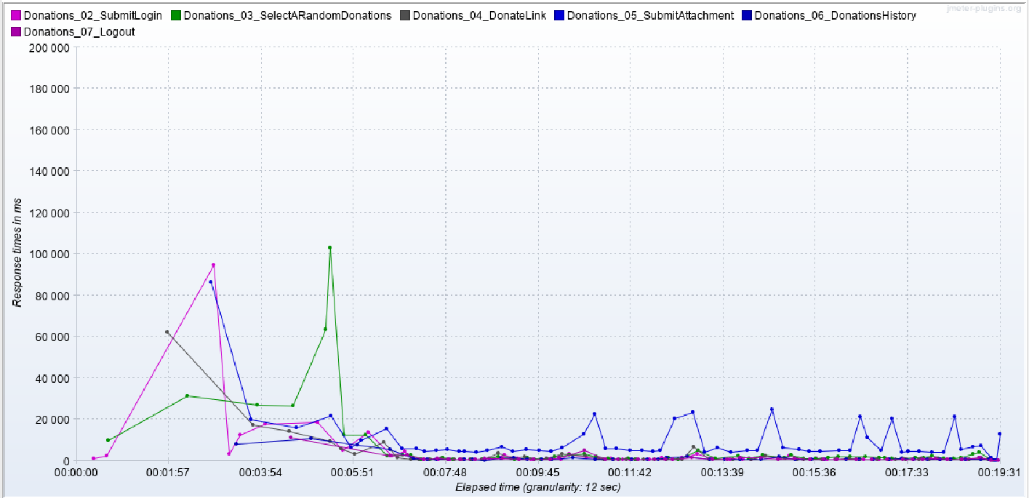

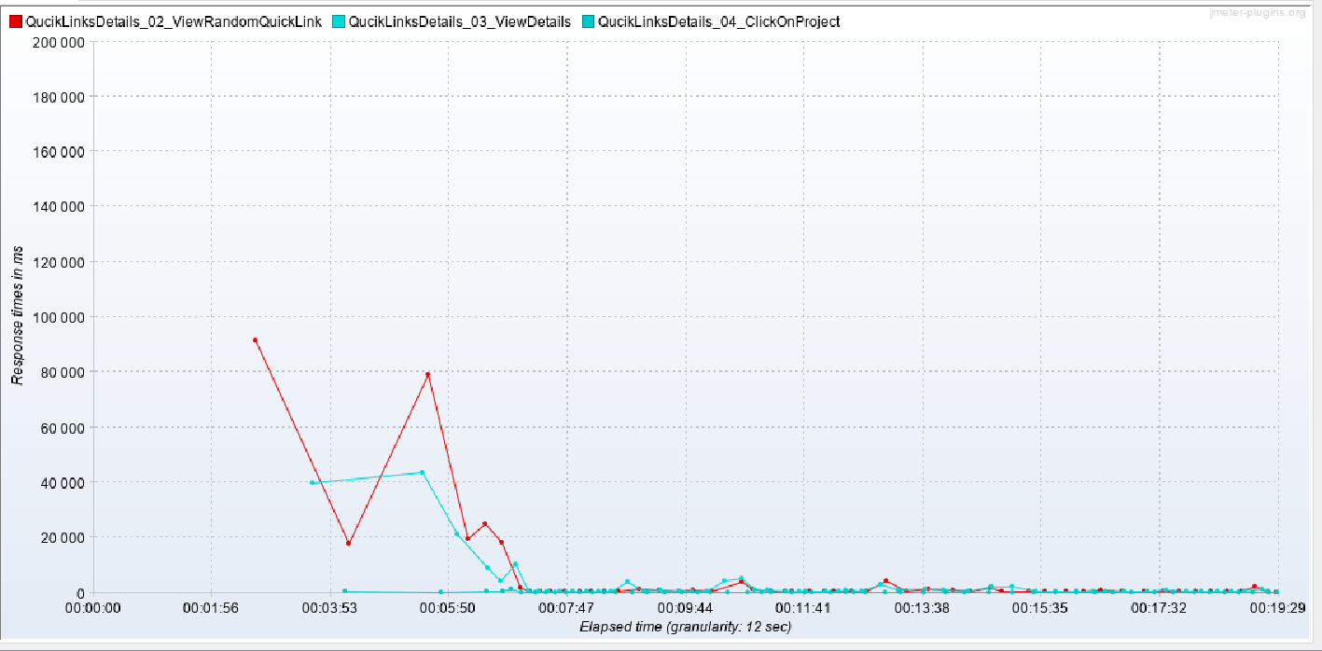

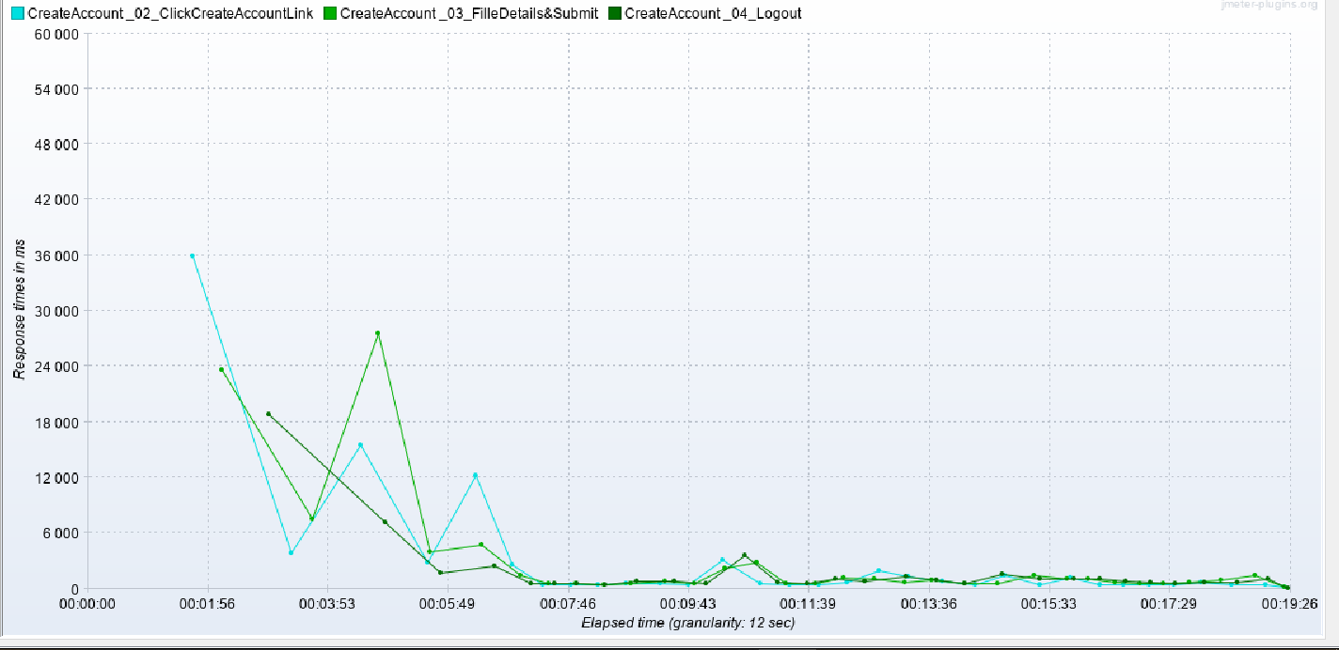

# Random Snap shots of Error

